South West Clinical Senate – Operating Principles

Document created:
Version: V0.1
This version updated: 19 August 2022

Document Version Control
October 2014 |  | Clinical Review role added to Senate portfolio and updated
September 2015 |  | New membership agreed and updated (see note regarding the proposed revision to Operating Principles)
January 2017 |  | Detail of developed Clinical Review Role and process added and membership increased from 28 to 36
April 2019 |  | Council Terms of Reference amended to reflect additional 10 council members (an increase from 36 to 47) with STP (6) and Clinical Network (4) leads added as well as NICE input. New merged management structure of NHSE and NHSI referenced
April 2021 |  | General review and amendments - updating the Head of Senate details, updating the council roles, etc
August 2021 |  | Added section on Senate Vice Chair, updated Council membership
December 2021 | V0.1 | Updated the section on Clinical Reference Group replacing this with the South West Clinical Senate Ethics Advisory Group
June 2022 | V0.1
June 2022 | V0.2 | Further revisions
June 2022 | V0.3 | Further revisions following comments from Chair and Vice Chair of SW Clinical Senate.
August 2022 | V0.1 | Updated Clinical Senate Map, general editing

Table of Contents
Document Version Control 1
Vision 5
Summary 5
Introduction 6
Objectives 6
The Role of the Clinical Senate 7
Values 7
Accountability 8
Clinical Senate Structure 8
Senate Chair 8
Senate Vice Chair 8
The Senate Assembly 8
Citizens’ Assembly 10
The Role of the Chair of the Citizens’ Assembly 11
Senate Council 11
The Senate Management Team 11
Management team members 12
Head of Clinical Senate 12
Issues for Deliberation 12
Deliberative Sessions 13
South West Clinical Senate Ethics Advisory Group 13
Clinical Review Process 14
Background 14
Administration 16
Appendix 1 17
Terms of Reference - South West Clinical Senate Council 17
Accountability 18
Relationship to the Senate Assembly 18
Relationship to the Citizen’s Assembly 18
Membership 19
Term of Membership and Appointment Process 21
Frequency of Meetings 21
Quorate Attendance for Deliberative Meetings 21
Meetings 21
Public Attendance at Meetings 22
Decision Making 22
Advice from Deliberative Senate Council Meetings 22
Review of Terms of Reference 22
Appendix 2 23
Conflicts of Interest Policy 23
Introduction 23
Purpose 24
Definition of conflicts of interest 24
Direct financial interest 25
Indirect financial interest 25
Non-financial or personal interest 25
Conflict of loyalties 26
Arrangements for managing conflict of interest 26
Declaring and Registering Interests 27
Process for Registering and Managing Conflicts of Interests 28
Registration of Potential Conflict of Interest Template 29
Appendix 3 30
Process for posing questions to the Clinical Senate 30
Submitting a Request 31
Appendix 4 32
Map of 9 Clinical Senates across England 32
Appendix 5 33
Application for membership of South West Clinical Senate Council 33
Appendix 6 35
South West Process Summary for Clinical Review Panels 35
Process Summary 35
Clinical review team members 36
Clinical Review: Terms of Reference Template 38
Clinical review team members 38
Aims and objectives of the clinical review 39
Scope of the review 39
Timeline 39
Reporting arrangements 39
Methodology 39
Report 39
Communication and media handling 39
Resources 39
Accountability and Governance 40
Functions, responsibilities, and roles 40
Appendix 7 43
South West Clinical Senate Reviews 43
Checklist Information from Commissioning body: Clinical Evidence (Key Service Change Tests 3 & 5) 43
Proposed Panel Questions to start (plus any they add once they have reviewed documents) 45
Appendix 8 46
South West Clinical Senate Clinical Review Panel Confidentiality Agreement 46

Vision
The Clinical Senate acts as the collective conscience of health and social care by providing independent clinical advice to commissioners to help develop high-quality services and sustainable healthcare for the population of the South West.

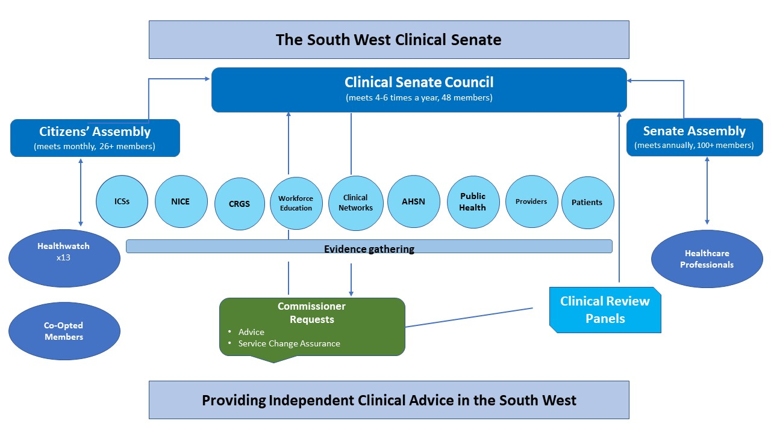

Summary
  - Clinical Senates were set up as a result of the Future Forum consultation before the Health and Social Care Act of 2012 to harness a wider range of clinical professional input beyond Commissioning bodies into the commissioning process.
  - NHS England describes the Clinical Senate as the body that ‘brings together a range of professionals to take an overview of health and healthcare for local populations and provide a source of strategic, independent advice and leadership on how services should be designed to provide the best overall care and outcomes for patients’.

Introduction
  - The South West Clinical Senate spans professional groups and works alongside patient and public partners, Clinical Networks, Academic Health Science Networks, and others to advise on service design, reconfiguration, and improve the quality of health and social care across the South West.
  - The Clinical Senate is a non-statutory organisation with no executive authority or legal obligations, which, in providing advice to commissioners, will take a broad and independent view on the totality of health and social care.
  - By harnessing collective expertise and intelligence from across the region and further afield as required, the Clinical Senate is positioned as a valued partner in the commissioning landscape and bring a renewed professional focus to the challenges facing health communities.
  - To be effective and credible, Clinical Senate membership needs to be multi-disciplinary, geographically representative, and span a variety of organisation types. Members will usually be senior clinical experts with strategic ability and be held in high regard in their respective fields. Members will be expected to decouple institutional allegiances and obligations from their advisory role on the Clinical Senate. The basis on which membership is founded will evolve.
  - Clinical Senates have the opportunity to develop professional consensus and critique to help commissioners and local health communities make effective decisions about quality, equity, safety, and efficiency. The challenges faced by the NHS mean that the Clinical Senate will at times make unpopular recommendations. It is anticipated that as the Clinical Senate matures, it will become proactive as well as responsive.

Objectives
  - The Clinical Senate will provide highly regarded and valued independent clinical advice that can be implemented across the South West region and beyond.
  - The Clinical Senate will be recognised as being valuable to the healthcare community and provide leadership in system transformation and reconfiguration.

The Role of the Clinical Senate
  - The role of the Clinical Senate is:
  - To provide a forum where collective knowledge, advice, and intelligence on health and social care issues can be shared and independent clinical advice provided to commissioners.
  - To provide a mechanism for increased participation in service change from clinicians and service users.
  - To support large-scale service change and service reconfiguration where appropriate, by providing independent clinical advice to improve the quality of health and social care across the South West.
  - To deliver an independent clinical review of the clinical models and evidence base for large-scale service change as part of the NHS England Assurance Process. This role was formerly delivered by the national Clinical Assurance Team (NCAT) and was taken on by the Clinical Senates.
  - To ensure a consistent approach, the 9 Clinical Senates across England developed a shared Standard Operating Framework (SOF) which describes the role of Clinical Senates both in providing advice and undertaking clinical reviews. The South West Clinical Senate's local guidelines are in adherence with this SOF which can be found on the South West Clinical Senate’s website. Please follow link: Clinical-Senate-Single-Operating-Framework-2014-15v3-July2014.pdf (swsenate.nhs.uk)

Values
  - The Clinical Senate should work to the Seven Principles of Public Life, known as the Nolan Principles, which were defined by the Committee for Standards in Public Life as follows:
  - Selflessness
  - Integrity
  - Objectivity
  - Accountability
  - Openness
  - Honesty
  - Leadership

Accountability
  - Clinical Senates have been established to be responsive to the health community through their deliberations and advisory role. The Clinical Senate will report to the South Regional Clinical Senate Co-ordinating Group and be accountable to the South West Medical Director, NHS England.

Clinical Senate Structure
  - The South West Clinical Senate will comprise a Senate Assembly and a Senate Council supported by a core management team and an independent Citizens’ Assembly.

Senate Chair
  - The Senate Chair is a clinician, appointed by interview and accountable to NHS England via the Medical Director of the Regional Team with responsibility for Clinical Senates and Clinical Networks. The Senate Chair has ultimate responsibility for the Senate. This is a renumerated role at 2PAs per week
  - The Senate Chair is responsible for appointing members of the Senate Assembly to the Senate Council via formal application and review with the Senate Management Team to ensure the Senate is credible both professionally and geographically.

Senate Vice Chair
  - The Senate Vice Chair is a clinician and council member, appointed by application and interview if necessary accountable to NHS England via the Medical Director of the Regional Team with responsibility for Clinical Senates and Clinical Networks. This is a remunerated role at 0.5PAs per week. The Senate Vice Chair supports the Chair in the leadership of the Senate.

The Senate Assembly
  - The Senate Assembly is a diverse multi-disciplinary professional collective providing the Senate Council with access to experts with a wide range of experience and ability from across the South West. Membership will encompass the 'pre-conception to death' spectrum of care across all health and social care settings. Members will be expected to decouple institutional obligations from their advisory role on the Senate. To be effective and credible, the Assembly members will be geographically representative, multi-professional, and span a variety of different organisation types.
  - The Senate work plan will inevitably require it to seek advice and views from individuals who are not assembly members. In doing so, it will ensure appropriate stakeholder consultation including where appropriate, the views of Royal Colleges and other professional organisations.
  - Senate Council membership will be drawn from the Senate Assembly where possible. Senate Assembly members not on the Council will not usually attend Senate Council meetings unless they are presenting evidence.
  - The key function of the Senate Assembly is to:
  - Comment on and provide evidence, perspective, and information on questions/topics being addressed by the Senate Council (including those pertinent to the South West Clinical Senate Ethical Advisory Group (SWCSEAG) function established under the umbrella of the Senate in 2021*)
  - Provide wide-ranging knowledge and expertise the Senate Council can draw on
  - Champion the role of the Clinical Senate
  - Help to set the annual work plan for the Senate Council and propose potential topics and or/questions that commissioners may wish to put forward
  - Sit on Clinical Review Panels as appropriate
  - Help to identify contributors for Clinical Review Panels
  - All members of the Senate Assembly will be invited to an annual event, which will cover issues including future priorities as well as offer continuing professional development opportunities.
  - Senior health and social care professionals working in the South West can apply to become Senate Assembly Members via online applications. These must be approved by the Senate Chair and one other member of the Senate Council. Senior non-clinical managers can be co-opted onto the Assembly by existing members of the Senate Council. There is currently no cap on the number of Senate Assembly members.

Citizens’ Assembly
  - A Citizens’ Assembly has been established to provide a strong patient and public voice to support the work of the Senate. The core membership seeks to comprise two representatives from each of the 13 Healthwatch organisations across the South West region and other co-opted members agreed upon by Citizens' Assembly members. It is chaired by an appointed and remunerated Citizens’ Assembly Chair.
  - The Citizens’ Assembly is an integral part of the infrastructure of the Senate enabling it to deliver its advice to commissioners with the full involvement of patient members.
  - The Citizens’ Assembly will debate issues of strategic importance brought to the Senate, drawing on evidence and information from its ‘network of networks’ that gather the patient voice, and consider potential areas of concern to patients and the public across the South West.
  - The Citizens’ Assembly has two places on the Senate Council. The Chair is a standing member of the Senate Council supported by an additional Citizens’ Assembly member (who is chosen to attend depending on interest/ knowledge of the topic to be discussed at the Senate Council meeting). The Deputy Chair of the Citizens’ Assembly will attend Senate Council meetings, in the absence of the Chair, to give voice to the patient, service user, and carer perspectives.
  - The key functions of the Citizens’ Assembly are to:
    - Bring patient, carer, and public perspective and appropriate challenge to the development of Clinical Senate recommendations and advice. This may include suggesting topics or questions to Commissioners or the Senate Council, to go forward to deliberative Senate Council meetings.
    - Use existing Healthwatch networks to hear the patient voice on questions before they go to Senate Council meetings for deliberation
    - Submit evidence to Senate Council Meetings
    - Share the advice that comes from the Senate Council
    - Sit on or find appropriate citizen contributors for Clinical Review Panels
    - Suggest topics that Commissioners may wish to seek Senate advice on.

The Role of the Chair of the Citizens’ Assembly
  - The Chair of the Citizens’ Assembly will make a significant contribution to the work of the Senate Council by:
  - Providing strong, coordinated, and coherent leadership of the Citizens’ Assembly.
  - Communicating the objectives and decisions of the Clinical Senate to the Citizens Assembly and associated South West-based patient and public forums.
  - Ensuring that patient experience informs the recommendations of the Clinical Senate to commissioners.
  - Working closely with the Senate Chair and Senate Manager to ensure patient and public participation is embedded in the work of the Senate.

Senate Council
  - The Senate Council will be the ‘steering group’ of the Clinical Senate and has its Terms of Reference (see Appendix 1)

The Senate Management Team
  - The Senate Management Team will be the initial contact point for the Clinical Senate. The team will meet monthly to plan the business of the Senate and will be responsible for its day-to-day operation. This will include the following:
  - Ensure regular and timely communication with Senate members and other key stakeholders
  - Ensure that the Senate’s deliberations and activities are consistent with its vision, objectives, and values
  - Identify and manage potential risks
  - Establish the operational policy of the Senate
  - Establish the annual work programme of the Senate
  - Establish a framework for evaluating the work of the Senate
  - Develop a methodology to measure success
  - Through liaison with neighbouring Senates, the Clinical Networks, NHS England &Providers, Commissioners, and other bodies, the Senate management team will ensure that cross-cutting themes are identified to avoid duplication and maximise the potential for collaboration.

Management team members
  - The Management Team members include:
  - Senate Chair & Senate Vice Chair
  - Assistant Director, South West Clinical Programmes and Networks
  - Head of Senate
  - Senate Officer
  - Senate administrator
  - Citizens' Assembly Chair

Head of Clinical Senate
  - The Head of Senate is appointed by and responsible to the Assistant Director, Clinical Programmes and Networks. The Head of the Senate is responsible for leading and organising the business of the Senate, providing the secretariat for its deliberations and clinical review panels, and ensuring an effective communications strategy.

Issues for Deliberation
  - Topics/requests for the Clinical Senate should come from or through:
  - Commissioners with a Lead commissioner acting as the sponsor for the proposal. These could be:
  - Integrated Care Boards or Systems
  - NHS England
  - Specialised Commissioning
  - Local Authorities
  - Health and Well Being Boards, acting in concert, where appropriate
  - Members of the Clinical Networks acting through the Clinical Director and in concert with a sponsoring commissioner
  - Provider organisations
  - Proposed by the Senate to a Commissioner
  - The Senate Council should assess the relevance of the discussion topics; however, the following principles guide the determination of issues for deliberation by the Clinical Senate:
  - The proposed discussion topics should be issues to which the Senate can add value.
  - While the Clinical Senate is clinical in its membership, discussion topics should not be restricted to those having a clinical basis.
  - Proposed topics should be of significant and of strategic importance to health and social care transformation.
  - The Senate Council has 2 main approaches to considering issues:

Deliberative Sessions
  - Issues for consideration that meet the criteria above will be allocated to a deliberative session of the council.
  - Each session will have a clear question that is to be addressed that is agreed with the “commissioning body”
  - The Senate team will ensure inputs from reference material and subject matter experts to inform the discussion
  - Council members, relevant assembly members, subject matter experts, and wider stakeholders will be invited to join the discussion
  - A report endorsed by the Senate will be provided to the commissioner and unless there is a specific reason not to do so, published on the Senate website.

South West Clinical Senate Ethics Advisory Group
  - In response to the Covid19 pandemic, the Clinical Senate demonstrated an ability to mobilise quickly and provide rapid multidisciplinary clinical advice on challenging clinical problems with an ethical or moral dimension. This function has now been embraced into the operating principles of the Clinical Senate.
  - Issues for consideration, which meet the criteria above, will be communicated to the Senate Team by an NHSE clinical leader with a clear timescale for response.
  - Clinical perspectives of council members, relevant assembly members, and wider stakeholders will be elicited either through a coordinated desktop review of documentation or a virtual meeting.
  - A report endorsed by the Senate will be provided and unless there is a specific reason not to do so, published on the Senate website.

Clinical Review Process

Background
  - Since September 2014, the 9 Clinical Senates across England have taken on the role formerly delivered by the National Clinical Assurance Team (NCAT) which ceased to exist as of April 2014.
  - NHS England has a role to support and assure the development of proposals for service change by commissioners via its Assurance Process. The stage 2 assurance checkpoint considers whether proposals for large-scale service change meet the Department of Health's 5 tests for service change, before going ahead to public consultation. The Senate considers “test 3”, the evidence base for the clinical model, and “test 5”, the case for changes to bed numbers.
  - It is this role that NCAT delivered previously and which Senates have taken on as an independent clinical advisory body. The other elements of service change which are reviewed by the assurance team (patient engagement, patient choice, quality benefits, fit with best practice, etc.) are not within the Senate’s remit.

Clinical Review Process
Initial discussion with the lead Commissioning body/Assurance Team (rolling review of reconfiguration grids). TOR agreed between the Commissioning body and the Clinical Senate.

Commissioning body share Case for Change and Summary of proposals

Stage 1 Sense-Check by Clinical Senate
(Via a small ‘virtual’ panel of Clinical Senate Clinicians). This panel will consider and provide feedback on the following.
1. Is the clinical case for change robust and in line with national best practice and evidence?
2. Is the outlined model clear and will it improve the quality of care?
3. Does the clinical case for change fit with the proposed changes?
4. What might need to be incorporated in future iterations of the model of care, when developing detailed options and where is further information needed?

Pre-Panel Pre-Meet
A couple of weeks before the full panel meeting it is helpful for the core Senate Team (Clinical Chair and Manager to meet with the core Clinical Leads on the project/programme team)

Clinical Review Panel
This would bring together a panel of out-of-area clinicians relevant to the topic area who would review service change documentation and pre-reading and meet with clinical leads as a panel to act as a critical friend and review whether the clinical evidence base for the options laid out is robust. A checklist for the stage 2 review can be found in appendix 7.

This would happen after commissioners have developed options and before they go to public consultation. This is a recommended part of the NHSE stage 2 assurance checkpoint that gives the go-ahead for service change proceeding to public consultation.

The Senate needs at least 8 weeks’ notice to set a date for a full clinical review panel and the final Pre-Consultation Business Case needs to be available to this panel 2 weeks before they convene. (Once set the date cannot be easily moved.)

Clinical Review Report
The panel summary can be shared with the Commissioning body and assurance team in the days immediately after the panel assuming no further information is needed. A full draft report with any recommendations will be signed off by the panel and shared with the Commissioning body for fact-checking within 3 weeks. A final draft should be available within 4 weeks.

The NHS England Assurance Process is shown below:
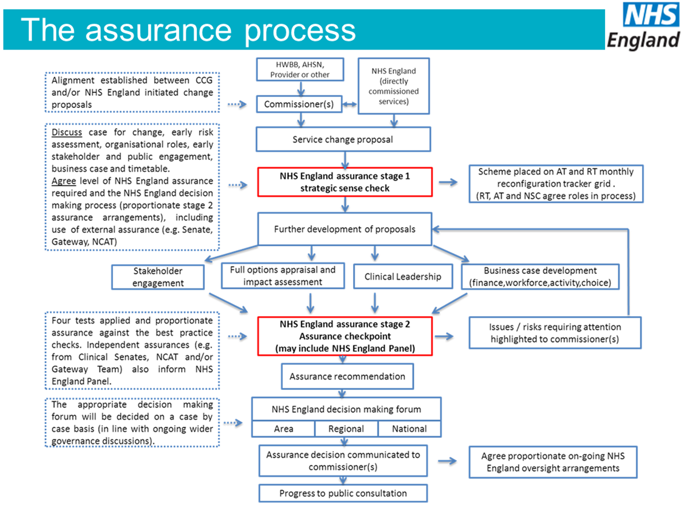
  - A South West Summary of the National Terms of Reference for the Clinical Review Panels has been developed (See Appendix 6).
  - A handbook for Clinical Review Panel Members has also been developed and is available from the Senate office.
  - Review Panels will be chaired by a Senate Council member, usually the Chair or Vice Chair, and will be run in addition to Senate Council meetings.

Administration
  - Secretariat for the Senate will be provided through the Senate Management Team.
  - The secretariat will ensure that the Senate has an effective means of communication with all stakeholders.

Appendix 1

Terms of Reference - South West Clinical Senate Council
  - The Senate Council is the 'steering group' of the Senate, led by the Senate Chair and consisting of a core membership of senior health and social care leaders, clinical experts, and patient and public representatives. As far as possible, the selection of Senate Council members will be geographically and professionally distributed.
  - The Senate Council members will be drawn from the Senate Assembly and two lay members will be drawn from the Citizens’ Assembly.
  - The Senate Council will take an overview of the strategic direction and business of the Senate by:
  - Agreeing on the Terms of Reference for the Senate
  - Developing and publishing a set of operating principles and values that guide the Clinical Senate
  - Being responsible for the formulation and provision of independent clinical advice to commissioners
  - Agreeing on the key priorities for the Senate in consultation with the health and social care system
  - Agreeing on the Terms of Reference for Clinical Review Panels, helps identify Clinical Review Panel members and sign off Clinical Review Panel reports. Some of this work may be done outside of scheduled Senate Council meetings.
  - Senate Council Members must:
  - Actively contribute to deliberative sessions and review evidence ahead of Senate Council meetings.
  - Endeavour to attend all meetings in full but ensure attendance at a minimum of 3 Senate council meetings per year.
  - Act in a professional capacity, with objectivity, and without organisational bias.
  - Adhere to the Conflicts of Interest Policy (See Appendix 2)
  - Adhere to the Code of Conduct for Senate Council Members
  - Act in a horizon scanning capacity, bringing question proposals to the Senate where appropriate
  - Support the role of Clinical Review
  - Champion the role of the Clinical Senate and encourage applications to the Senate Assembly

Accountability
  - The Senate Council is held accountable to the NHS South West Medical Directorate for the business of the Senate, but not for its deliberations and advice given.

Relationship to the Senate Assembly
  - Membership of the Senate Council is largely drawn from the Senate Assembly. The full Senate Assembly will meet at least once a year. The key functions of the Senate Assembly are to:
  - Provide evidence on questions being addressed by the Council
  - Provide wide-ranging knowledge and expertise the Senate Council can draw on
  - Champion the role of the Clinical Senate
  - Help to set the annual work plan for the Senate Council and propose potential topics and or/questions that commissioners may wish to put forward
  - Sit on Clinical Review Panels as appropriate
  - Help to identify contributors for Clinical Review Panels

Relationship to the Citizen’s Assembly
  - The Citizen’s Assembly comprises representatives from the 13 Healthwatch organisations across the South West as well as individuals who regularly link with local networks and community groups. The Citizen’s Assembly is chaired by a Citizens’ Assembly Chair who sits on the Senate Council along with 1 other Citizen’s Assembly member nominated to each council meeting on a topic-specific basis. The key functions of the Citizen’s Assembly are to:
  - Contribute to Senate Council deliberative sessions through its 2 nominated Senate Council Members.
  - Use existing Healthwatch networks to hear the patient voice on questions before they go to Senate Council meetings for deliberation
  - Submit evidence to Senate Council Meetings
  - Share the advice that comes from the Senate Council
  - Sit on or find appropriate citizen contributors for Clinical Review Panels
  - Suggest topics that Commissioners may wish to seek Senate advice on.

Membership
  - The updated council members agreed for 2022 is as follows:
  - Standing Members (8)
- Independent Chair (appointed by NHSE)
- Vice Chair (appointed from within the Senate Council)
- Citizens' Assembly Members x (2) [Chair/ Deputy & another member selected on a topic-specific basis]
- Regional Director of Public Health or their nominee
- Workforce/ Education representative
- Academic Health Science Network (AHSN) X2 representatives

  - Core Members (38)
Clinicians from any discipline with regional, sub-regional or national experience in the following clinical areas
Medicine | 4
Critical Care | 1
Surgery | 4
Women's Health | 1
Children's Health | 3
Mental health | 2
Care of older people | 2
Emergency care | 1
Prehospital emergency care | 1
Cancer care | 2
Diagnostic services (includes radiology) | 1
Pharmaceutical services | 1
Dentistry | 1
Community services | 2
Social care | 2
Primary Care | 2
Public Health | 1

Clinicians from the following disciplines
Medical professional | 2
Nursing or midwifery professional | 2
Medical scientist | 1
Allied health professional | 3
Clinical manager/leader | 1

  - Co-opted Membership
ICS Clinical Leads (7)
ICS Clinical Lead BNSSG | ICS Clinical Lead Somerset
ICS Clinical Lead BSW | ICS Clinical Lead Cornwall
ICS Clinical Lead Devon | ICS Clinical Lead Dorset
ICS Clinical Lead Gloucestershire

  - Non-Voting/Invited
Professional-in-training (2) [12-month opportunity for doctors, nurses, Allied Health professionals]
National Institute for Health and Care Excellence (Regional Field Team)

  - There is an open invitation to Clinical Leads from the region’s Clinical Networks, to join the Senate Council
  - Senate Council members may not send proxies where they are unable to attend in person to maintain the dynamics, and modus operandi of the group.
  - The Medical Director, Senate Associate Director, Head of Senate, Senate Officer, and an administrator may be in attendance.
  - Additional assembly members will be co-opted as required for deliberative sessions

NB. Members drawn from the Senate Assembly must together represent the broad geography and range of health and social care organisations and professions across the South West.

Term of Membership and Appointment Process
  - Senate Council members will be appointed for 1, 2, or 3 years at their discretion. At the end of a 3-year term, the Council place will be declared vacant but previous council members are permitted to reapply and be reappointed.
  - New Senate Council members will be recruited from the Senate Assembly via an application process (see appendix 5). Applications will be reviewed by the Senate Management Team with a selection process where there are more applicants for any one position. Consideration will be given to ensure the Senate Council remains credible both professionally and geographically.
  - A phased approach will be adopted to selecting and appointing new members to retain and hand over expertise, aiming for complete renewal of the Senate Council over 5 years.
  - Standing members will be appointed following a nomination from their employing organisation

Frequency of Meetings
  - The Senate Council will meet bi-monthly with no fewer than 4 meetings per year. Business meetings to review Terms of Reference etc. may also be scheduled as appropriate.

Quorate Attendance for Deliberative Meetings
  - The quorum for attendance at Senate deliberations is greater than 50%

Meetings
  - The Senate Council Meetings will be supported by the Senate Management Team. Papers for the meetings will be sent out at least a week in advance. Notes will be processed within two weeks.
  - The core agenda will include three sessions applicable to general advice topics or where senate council meetings are used for clinical review panels to take place:
  - Evidence review
  - Deliberation
  - Decision-making and rationale
  - To ensure that a full and robust analysis of the evidence is available, additional expertise may be sought through the calling of expert contributors that could include patients or service users and their carers.

Public Attendance at Meetings
  - Members of the public may attend the first part of a deliberative meeting to hear the evidence, including patient and public evidence, presented to the Senate Council, and will be allowed to comment. The deliberative component of the meetings will be documented but not held in public. This does not include council meetings used to run clinical review panels where much of the Commissioning body evidence will be confidential and not for onward or public sharing at that point in time.

Decision Making
  - While various groups may nominate Senate members, decisions leading to recommendations will be made in the best interest of the health system, above any sectional or vested interests of Senate members. Decisions will be made with the support of evidence presented to all Senate members and will be made publicly available. The Senate Council and Chair will avoid making decisions by vote where possible. Where a consensus approach to decision-making is not possible, decisions may be determined by a majority vote with the Senate Chair holding the decisive vote. NHS England staff members do not have the right to vote.

Advice from Deliberative Senate Council Meetings
  - At the end of each deliberative meeting, the Senate Council Chair will summarise the advice reached on the day and this will be shared via email with Senate Council members within a week, post-council meeting. Formal advice for commissioners will be circulated and shared with wider stakeholders on the Senate website within 6 weeks.

Review of Terms of Reference
  - Once agreed, the Terms of Reference for the Senate Council will be reviewed yearly.
  - These Terms of Reference are next due for review in August 2022.

Appendix 2

Conflicts of Interest Policy

Introduction
  - This policy sets out how the South West Clinical Senate will manage conflicts and potential conflicts of interest.
  - This policy draws on examples from other Clinical Senates and NHS organisations.
  - This policy will cover members of The Senate Assembly and Citizens’ Assembly including all Council members and the Senate Management team as well as relevant individuals who have been commissioned to give evidence at Senate Council meetings or undertake any work on behalf of the Senate.
  - This policy aims to provide transparency and assurance to all stakeholders.
  - Members of the Senate Council need to demonstrate that the advice they give:
- meets local health needs and that these have been considered appropriately
- goes beyond the scope of a single provider or organisation
- is in the best interests of the public and patients
  - This policy supports a culture of openness and transparency. All Senate members are required to:
- ensure that the best interests of patients always remain paramount
- be impartial and honest in their conduct as a Senate member
- ensure that they do not abuse any professional or personal position for personal gain or to the benefit of their family or friends

Policy Statement
Members of the South West Clinical Senate Council should act in good faith and the interests of the Senate and comply with this Conflicts of Interest policy.
Individuals appointed or commissioned to work on behalf of the South West Clinical Senate will be made aware of their obligation to declare conflicts or potential conflicts of interest.
This policy supplements and does not replace the code of conduct of the individual’s employing organisation. Ultimately, it is the responsibility of any individual to declare a known conflict.

Purpose
  - The purpose of this policy is to guide relevant individuals on handling possible conflicts of interest that may arise as a result of their role in the South West Clinical Senate.
  - This Policy:
- Defines what is meant by conflict of interest
- Sets out the process for managing conflict of interest within the South West Clinical Senate
  - Scope
- The policy covers the Assembly and Citizens' Assembly including the Senate Council and the Senate Management Team.
- This policy also applies to other individuals who may contribute to the work of the Senate e.g. submitting evidence to a deliberative council meeting or a clinical review panel*.
- Conflicts of interest may arise at Senate Council deliberative sessions, for individuals presenting evidence to the Senate, for the Citizens' Assembly in its contribution to Senate Council questions, and for the full Senate Assembly when commenting on questions going to the Senate council.
*Where individuals presenting evidence declare conflicts of interest, this does not necessarily mean they cannot participate in giving evidence as in attending as a witness their role will likely be biased in nature. However, conflicts of interests must still be declared to the Senate Council in all cases.

Definition of conflicts of interest
  - A conflict of interest can be defined as any situation in which a member’s responsibilities or interests, professional or personal, may, or may appear, to affect the impartiality of the Clinical Senate’s advice. It is important to state, however, that members of the Clinical Senate Council have been appointed or nominated in large part because of the particular knowledge or expertise that they can bring to the Council and this may relate directly to the professional responsibilities that they hold. This policy aims to ensure that actual or potential conflicts, which will arise, are acknowledged, and managed transparently.
  - The most common types of conflicts of interest include:

Direct financial interest
  - An individual may personally financially benefit from the consequences of a commissioning decision (for example, as a provider of services). This may arise as a result of holding an office or share in a private company that may be referred to in Senate deliberations or that could potentially bid to provide services that the Senate might advise on.

Indirect financial interest
  - An individual is a partner, member, employee, or shareholder in an organisation that will benefit financially from the consequences of a commissioning decision. Indirect financial interest can also occur when a close relative may benefit financially from the advice of the Senate
  - The positions which might create real or perceived conflict due to financial interests include:
- Directorships
- Ownership or part-ownership of private companies, businesses, or consultancies likely or possibly seeking to do business with the NHS
- Majority or controlling shareholdings in organisations likely or possibly seeking to do business with the NHS
- A position of authority in a charity or voluntary organisation contracting for NHS services
- Research funding/grants that may be received by an individual or their department
- Interests in pooled funds that are under separate management.

Non-financial or personal interest
  - A Clinical Senate member receives no financial benefit but is influenced by external factors such as gaining some other intangible benefit or kudos. For example, the Senate provides advice which results in awarding contracts to a Senate member’s friends or personal business contacts.
  - Where an individual holds a non-remunerative or not-for-profit interest in an organisation, which will benefit from the consequences of a commissioning decision (for example, where an individual is a trustee of a voluntary provider that is bidding for a contract).
  - Where an individual may enjoy a qualitative benefit from the consequence of a commissioning decision that cannot be given a monetary value (for example, a reconfiguration of hospital services which might result in the closure of a busy clinic next door to an individual’s house).

Conflict of loyalties
  - This may occur when decision-makers have competing loyalties between the organisation to which they have the primary duty and some other person or entity. For healthcare professionals, this could include loyalties to a particular professional body, society, or special interest group. This could also involve an interest in a condition or treatment due to an individual’s own experience or that of a family member.
  - This can include situations where Senate Council members are likely to have long-standing professional relationships with colleagues affected by commissioning advice, to whom they may have allegiances as peers, and with whom they developed ways of working over a period of time. Personal conflicts could therefore exist when advice is made which could affect such relationships in some way.
  - If in doubt, the individual concerned should assume that a potential conflict of interest exists.

Arrangements for managing conflict of interest
  - All council members will be asked on an annual basis to submit a written declaration of interest.
  - All witnesses giving evidence to the Senate will be asked to complete declarations of Conflicts of Interest where applicable.
  - Declarations of conflicts of interest will be added to the agenda for all Senate Council deliberative sessions. Due to the single topic-based format of Senate Council deliberative meetings, it is possible that a conflict of interest could arise for the same individual at one meeting but not at another. It is therefore the responsibility of all individuals attending or contributing to Senate meetings, even where potential conflicts of interests have already been raised, to declare this at the earliest opportunity or the latest at the meeting.
  - If a conflict of interest that has not yet been declared becomes apparent during a meeting, Senate members are obliged to make a verbal declaration before witnesses and provide a written declaration as soon as possible thereafter. Any declarations of interest and arrangements agreed upon in any meeting will be recorded in the notes and transcript of the meeting.
  - Where any conflicts of interest are declared, the Council Chair will determine whether such interests amount to a sufficient conflict of interest to require that the member or members stand down from the discussions and whether there is a need to co-opt a temporary member or members to assist the Senate Council in its deliberations.
  - Where the Chair or a majority of the Senate Council members are concerned that there is a persistent or serious breach of the governance or standards by a member or members, the Chair or a majority of the membership may apply to the Medical Director to have that member or members removed from the Senate Council and replaced by the normal means of nomination or appointment.

Declaring and Registering Interests
  - All relevant staff, members, and other individuals involved in Senate work have a responsibility to be aware of the potential for a conflict of interest.
  - Such situations must be carefully managed to ensure that any conflict of interest does not detrimentally impact the work of the Senate, or confidence in the advice provided by the Senate.
  - The ultimate responsibility for the management of potential and actual conflicts of interest rests with the Council Chair.
  - Should any changes in circumstances arise, it is the responsibility of all Senate Assembly, Citizens' Assembly, and Management Team members to declare any interest or potential interest they have, in general, or about a proposed topic by writing to the Chair or Senate Manager or at the beginning of a Council meeting.
  - All potential conflicts of interest should be raised at the earliest opportunity.
  - Where the Senate Council Chair identifies any personal potential conflicts of interest, he should declare these to the Senate Management team. Where the Chair has a conflict of interest, previously declared or otherwise, about scheduled or likely business of the meeting she/he must make a declaration and the Vice Chair will act as Chair for the relevant part of the meeting.
  - All declarations of interest should be made as soon as they become apparent.
  - The South West Clinical Senate Management Team will update and maintain a confidential register of all declared conflicts or potential conflicts of interests relating to current Senate work with details of any arrangements agreed to manage these.
  - The Clinical Senate Management Team, on behalf of the Council Chair will ensure that for every interest declared, either in writing or by oral declaration, the arrangements provided by the Council Chair are communicated to the declarer.

Process for Registering and Managing Conflicts of Interests
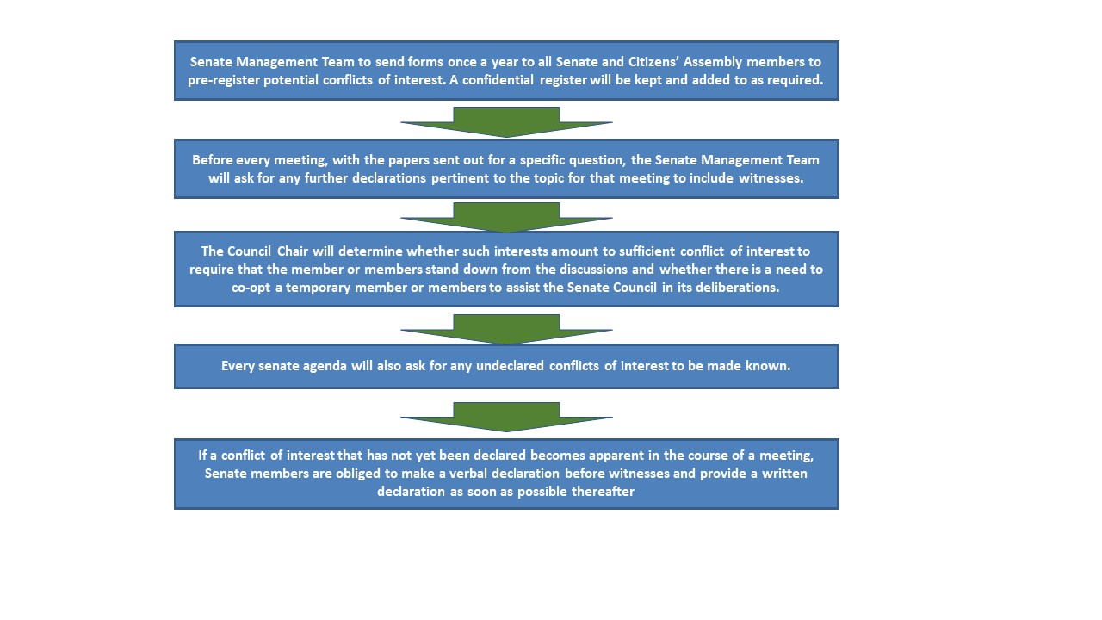

Registration of Potential Conflict of Interest Template
  - For advice on what items should and should not be declared on this form refer to the Conflicts of Interest Policy issued with Operating Principles for the South West Clinical Senate. Further advice can also be obtained from the Head of the Clinical Senate.

Name
Position
Please describe below any relationships, transactions, positions you hold, or circumstances that you believe could contribute to a conflict of interest
I hereby certify that the information set forth above is true and complete to the best of my knowledge.
Signature
Date:

Appendix 3

Process for posing questions to the Clinical Senate
“The Clinical Senate will coordinate the provision of robust and credible strategic clinical advice and clinical leadership to influence the provision of the best overall care and outcomes for their populations. “
  - The Clinical Senate will consider requests for advice from the following Commissioners:
- NHSE, and other healthcare teams in the South West
- Commissioning bodies
- Local Authorities
- Health and Wellbeing Boards
- Senate Council Members on behalf of Commissioners
  - The Clinical Senate will provide advice on the following issues in the South West:
- Matters of strategic importance to improving health and healthcare
- Matters relating to service transformation and reconfiguration e.g. models of care, quality and outcomes, development of sustainable local solutions
- Matters relating to quality improvement e.g. where quality standards do not exist
- Matters relating to quality assurance e.g. advice relating to the impact of service change proposals and post-implementation evaluation
  - The Clinical Senate will not provide advice on:
- Matters involving individual clinicians or patients
- The appropriateness of a procurement decision
- Strategic decisions that have already been made (although it may provide advice on issues relating to implementation)

Submitting a Request
  - A request for advice may be discussed with the Clinical Senate Council Chair or Head of Senate informally in the first instance.
  - A formal request for advice should then follow (a template and flowchart are available) and include a core set of information including a very clear statement on the nature of the advice required; the history of the issue, key stakeholders involved, and when the advice is required.
If the Clinical Senate identifies any significant concerns through its work that indicate risk to patients it will raise these immediately with relevant senior staff in the organisations involved and that depending on the nature of the issues identified the Clinical Senate Council may be obliged to raise these with the relevant regulatory body(ies).

Appendix 4

Map of 9 Clinical Senates across England

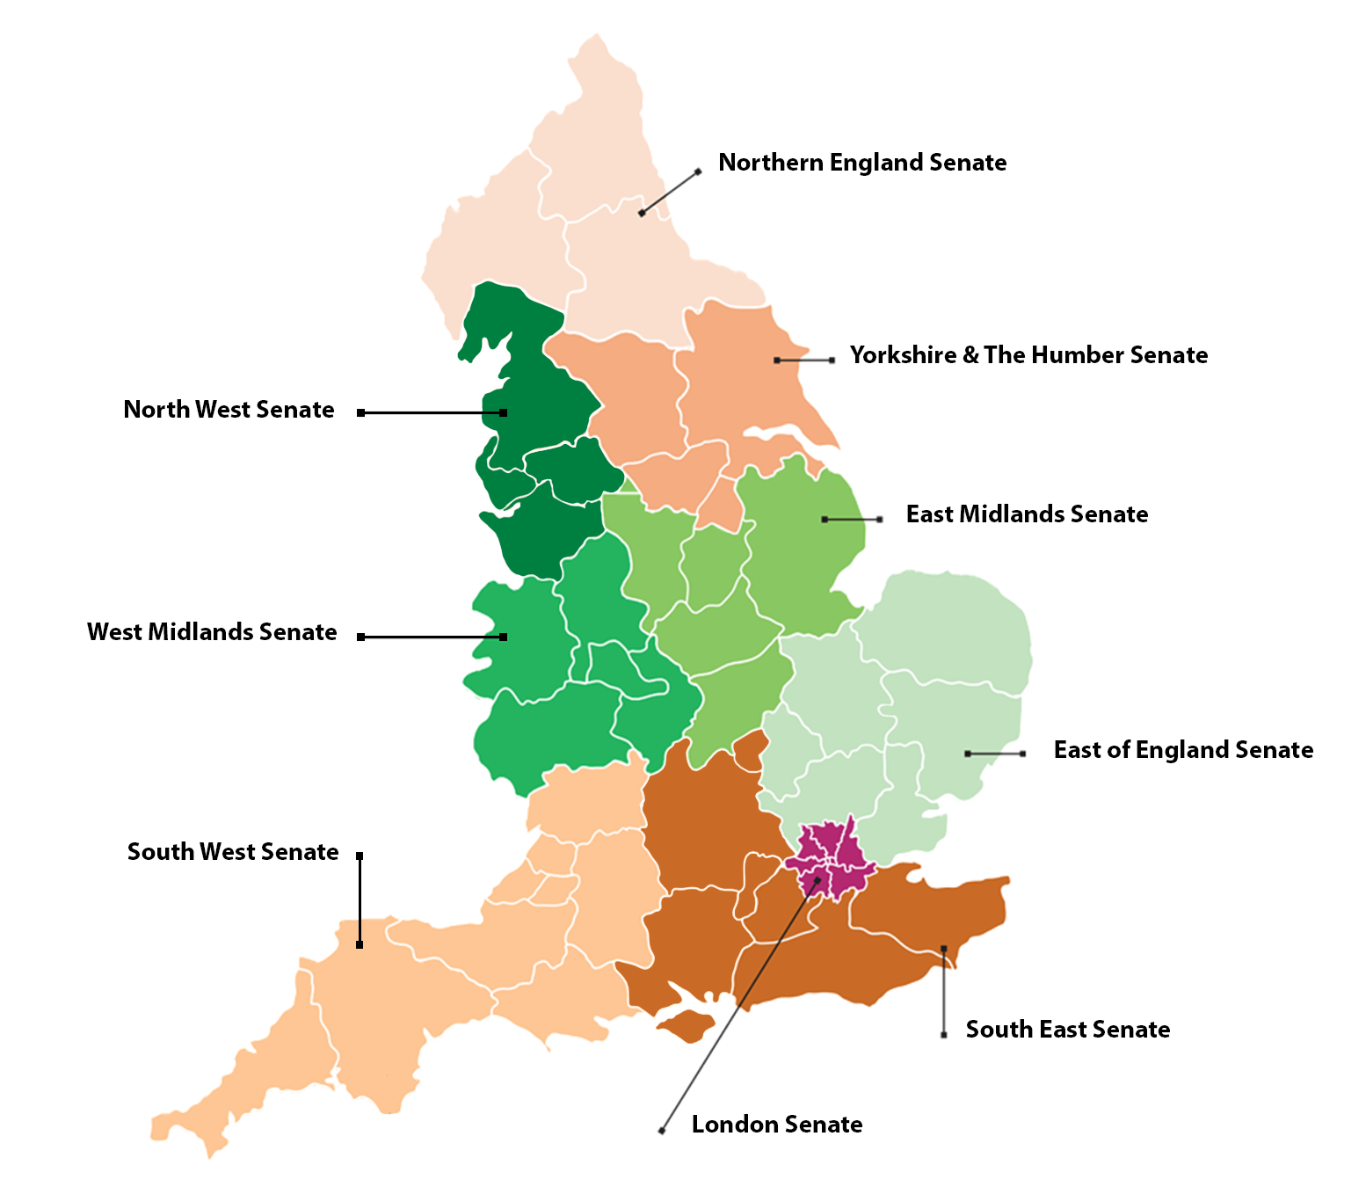

Appendix 5

Application for membership of South West Clinical Senate Council
  - Applications should be submitted to Trish Trim, Senate Administrator patricia.trim@nhs.net.
  - There is no remuneration available for these roles and prospective Council members should obtain the agreement of their line manager before applying.
  - Council members will be expected to attend up to six all-day meetings (a minimum of 3 to retain membership) in Taunton per annum and make time available to read pre-meeting papers.
  - Appointments will be for one year, extendable by mutual agreement.
  - Prospective applicants are encouraged to contact Sally Pearson, Senate Chair (sally.pearson6@nhs.net or Ajike Alli-Ameh, Head of Senate ajike.alliameh@nhs.net for further information and discussion.
Name
Job title
Email address
Contact number
Address

Qualifications
Employing organisation
Please describe any leadership role(s) including dates held | National:
 | Regional:
 | Local:
Please describe any first-hand experience of patient pathway development in the last 2 years including the setting and role
Relevant experience, attributes, and reasons for applying. (up to 200 words)

Appendix 6

South West Process Summary for Clinical Review Panels
"The basis of any major service change or reconfiguration must be that the change will improve the quality of care and that it is clinically led and based on a clear clinical evidence base. Service change is often highly complex and attracts high levels of public interest. It is therefore important that schemes are appropriately assured so that communities can be reassured schemes are high quality, align with best practice, and will deliver the benefits expected." Clinical Review Process Guidance Note – August 2014
Clinical-Senate-review-process-guidance-note-final-July2014.pdf (swsenate.nhs.uk)

Process Summary
The below is taken from the Clinical Review Process Guidance Note – August 2014, referenced above, which is more comprehensive and details further information about the background to this process, suggested review methodology, conflicts of interest management, and confidentiality.
Notes in italics have been added locally by South West Senate (except where shown in the TOR template).
The request will come either from NHS England or the Sponsoring Commissioner and the Clinical Senate will need to develop a TOR including consideration of the following:
- A detailed timetable for a review should be agreed upon between the sponsoring organisation and the clinical senate and included in the terms of reference. Ideally, the request should be received at least three months in advance of the anticipated clinical review start date. The indicative timetable for a review should be confirmed at an early stage, to ensure that the review report is finalised in time to inform the NHS England assurance checkpoint.
- The actual timeline will be dependent upon the size, nature, complexity, and dependencies of the clinical review.
- The time required for the sponsoring organisation to bring together the necessary information and evidence to ensure the clinical review team is fully informed (it may be appropriate to confirm the timeline once this stage has been completed).
- The time required to inform the clinical review team, explore the issues, and prepare for interviews, meetings, etc.
- The expected time and duration of interviews, meetings, etc and follow-up review and team discussion
- Time for report writing
- The timeline should include a date for
  - draft report to the sponsoring organisation for factual accuracy (only)
  - the date the sponsoring organisation should respond to the clinical review team by
  - the council meeting for formal endorsement of advice and
  - submission of the final report to the sponsoring organisation
- The timeline should include dates and arrangements for publication and dissemination of the information

Clinical review team members
The Clinical Senate will need to establish a team of clinical experts to undertake the review. This multi-professional group will undertake the review and write the report. The size of the clinical review team should be relative and proportionate to the size, nature, and complexity of the topic and the available expertise.
- The Clinical Senate council will appoint an experienced and neutral Chair for the review.
- Membership of the clinical review team will be formed by professionals with relevant experience or understanding of the clinical issues under consideration. Clinical review teams should always include an appropriate number of citizen representatives.
- The clinical review team is likely to include members from within its clinical senate but may also include members of other clinical senates, or other invited relevant topic experts. For example, clinical specialists (who may, or may not, come from outside the senate geographical area) and strategic clinical network members.
- The team will not include any individuals who will be or have been, involved in any other part of the NHS England assurance process for this service change proposal.
- Suggested membership is available in the Terms of Reference template (below).
- Responsibility for the composition of the clinical review team will lie with the clinical senate council. This will be shared with the sponsoring organisation before the commencement of the review as part of the Terms of Reference.
- All clinical review team members will be required to sign a Declaration of Conflict of Interest (see section 6 below and Appendix ii) and a confidentiality agreement (Appendix iii). Their names and affiliations will be published in the clinical senate review report.
An overview of the Process which is expected to take 3 to 4 months from start to finish is shown below.

Clinical Review: Terms of Reference Template
Title:
Sponsoring Organisation:
Clinical Senate:
NHS England regional or area team:
Terms of reference agreed by:
(Name)
on behalf of (name) Clinical Senate and
(Name)
on behalf of sponsoring organisation (name)
Date:

Clinical review team members
Chair (appointed by clinical senate council chair)
The clinical review team is likely to include members from within its clinical senate but may also include members of other clinical senates, or other invited relevant topic experts. For example, clinical specialists (who may, or may not, come from outside the senate geographical area) and strategic clinical network members.
Members of the clinical review team should be drawn from the following: this is not an exclusive list but provided as a guide as membership will need to be appropriate to the topic under review:
- Patient / citizen representatives
- Commissioners: Commissioning bodies, NHS England Area Team
- Providers: primary, secondary, community, mental health, social care, other e.g. Ambulance trust
- Clinical experts
- Public Health

Aims and objectives of the clinical review
The clinical review team needs to have a clear focus on what it is being asked to do. Its focus should be on the areas agreed with the sponsoring organisation - the foundation of which is to test if there is ‘a clear clinical evidence base’ underpinning the proposals.

Scope of the review
[Clinical areas under consideration to be clearly defined]

Timeline
[Agreed timeline to be inserted, to include stages of early discussion, the establishment of the clinical review team, information gathering, team brief, review, consideration, report writing, reporting to council, commissioner feedback, and response date to sponsoring organisation]

Reporting arrangements
The clinical review team will report to the clinical senate council which will agree the report and is accountable for the advice contained in the final report.
The clinical senate council will submit the report to the sponsoring organisation and this clinical advice will be considered as part of the NHS England assurance process for service change proposals.

Methodology
[Define how the review will be undertaken, including information required in advance, approach to interviews, and any site visits. This should be agreed with the sponsoring organisations proposing the service change as they will need to support the review requests.]

Report
A draft clinical senate assurance report will be made to the sponsoring organisation for fact-checking before publication
Comments/corrections must be received within [x] working days.
The final report will be submitted to the sponsoring organisation by [date]

Communication and media handling
Dates and arrangements for publication and dissemination of report and associated information. To include identified lead person, where and when the report will be published, press releases/conferences, meetings with patent groups, public, staff and boards, health and wellbeing boards, and Health overview and scrutiny committees

Resources
The [regional] clinical senate will provide administrative support to the review team, including setting up the meetings and other duties as appropriate.
The clinical review team will request any additional resources, including the commissioning of any further work, from the sponsoring organisation.

Accountability and Governance
The clinical review team is part of the [regional] Clinical Senate accountability and governance structure.
The [regional] clinical senate is a non-statutory advisory body and will submit the report to the sponsoring organisation.
The sponsoring organisation remains accountable for decision making but the review report may wish to draw attention to any risks that the sponsoring organisation may wish to fully consider and address before progressing their proposals.

Functions, responsibilities, and roles
The sponsoring organisation will
- provide the clinical review panel with the case for change, options appraisal, and relevant background and current information, identifying relevant best practices and guidance. Background information may include, among other things, relevant data and activity, internal and external reviews and audits, impact assessments, relevant workforce information, and population projection, and evidence of alignment with national, regional, and local strategies and guidance (e.g. NHS Constitution and outcomes framework, Joint Strategic Needs Assessments, Commissioning bodies two and five-year plans and commissioning intentions). The sponsoring organisation will provide any other additional background information requested by the clinical review team.
- Provide a Summary of the Proposed changes using the template provided by the clinical senate.
- respond within the agreed timescale to the draft report on a matter of factual inaccuracy.
- undertake not to attempt to unduly influence any members of the clinical review team during the review.
- submit the final report to NHS England for inclusion in its formal service change assurance process.
The Clinical senate council and the sponsoring organisation will
- agree on the terms of reference for the clinical review, including scope, timelines, methodology, and reporting arrangements.
The Clinical Senate council will
- appoint a clinical review team, this may be formed by members of the Senate, external experts, and/or others with relevant expertise. It will appoint a chair or lead member.
- endorse the terms of reference, timetable, and methodology for the review
- consider the review recommendations and report (and may wish to make further recommendations)
- provide suitable support to the team and
- submit the final report to the sponsoring organisation
The Clinical review team will
- undertake its review in line with the methodology agreed in the terms of reference
- follow the report template and provide the sponsoring organisation with a draft report to check for factual inaccuracies.
- submit the draft report to the clinical senate council for comments and will consider any such comments and incorporate relevant amendments to the report. The team will subsequently submit the final draft of the report to the Clinical Senate Council.
- keep accurate notes of meetings.
The Clinical review team members will undertake to
- commit fully to the review and attend all briefings, meetings, interviews, panels, etc that are part of the review (as defined in the methodology).
- contribute fully to the process and review report
- to ensure that the report accurately represents the consensus of the clinical review team
- comply with a confidentiality agreement and does not discuss the scope of the review or the content of the draft or final report with anyone not immediately involved in it. Additionally, they will declare, to the chair or lead member of the clinical review team and the clinical senate manager, any conflict of interest before the start of the review and /or materialise during the review.
Notes for South West Clinical Senate Council
- Acknowledgement that Clinical Review does require specialty expertise but no geographical bias for its panels.
- Clinical Review Panels may need to be made up partially by assembly members from other areas.
- Senate Assembly, Citizens' Assembly & Council to be asked to endeavour to make themselves available as required, both in the South West and to neighbouring Clinical Senates, where Clinical Review topics relevant to their expertise come up.
- The Senate Council may be asked to sign off TOR and reports for Clinical Review Panels outside of scheduled advice meetings.
- The Chair of the Clinical Review Panel will present the summary of the report to the Senate Council.

Appendix 7

South West Clinical Senate Reviews
1.1 This checklist is a summary drawn from the West Midlands Clinical Senate document titled Stage Two Clinical Evidence Framework August 2016 which sets out advice to proposers in relation to the evidence to be developed in advance of an independent clinical review as part of NHSE Stage 2 assurance processes and which has been endorsed by the 10 Senates nationally.

Checklist Information from Commissioning body: Clinical Evidence (Key Service Change Tests 3 & 5)
Topic Area | Information | Evidence sought | Document Sent  (Case for Change and Pre-Consultation Business Case may be the only documents needed)
Healthcare Setting | Narrative summary of the current position concerning the services covered by proposals | Background – demography and service activity/outcomes
Model proposed | Why proposals for change need to be considered | Case for Change
 | How final options were developed and the clinical rationale | Options Appraisal
 | Which options were ruled out, and why? | Options Appraisal
 | What is the proposed model or models? | Proposed Model of Care
 | Scenarios to show how the proposed changes would affect patients | Key Benefits and Pathways, case studies
 | Clinical risks of implementing proposals | Risk Assessment
 | Expected outcomes and benefits of delivery | Proposed Model of Care, Key Benefits
 | Extent to which the community believes proposals will deliver real benefits | Engagement documentation
 | Impact proposals will have on services | Proposed model of care
Clinical Engagement | Evidence of clinical leadership and engagement in the development of the model and implementation plans (not just Commissioning body staff). | Proposed model of care, programme documentation
Programme Management | The decision-making process and timescales. | Model of Care and wider Programme documentation
Best Practice | Fit with clinical evidence and clinical best practice. | Proposed Model of Care
 | Link of proposals to wider commissioning plans, clinical guidelines, etc., alignment with STP | Other plans/models of care
Implementation and Clinical Outcomes | How changes would be implemented, including phasing, pathways, activity, activity type, and staffing modelling. | Pathways, activity, activity type, and staffing modelling.
 | What would happen to the premises. | Estates intentions
 | Expected changes in clinical outcomes. | Proposed model of care
 | Performance expectations and sustainability. | Proposed model of care
Of interest | Financial Summary
 | EIA
Other Documents Sent

Proposed Panel Questions to start (plus any they add once they have reviewed documents)

- Has there been any senate involvement to date? What was the advice?
- What are the proposals?
- How have they been arrived at?
- Are the proposals well thought through?
- What are the programme management arrangements?
- What clinical leadership is there behind the proposals?
- Are the proposals underpinned by a clear evidence base?
- Is the detail to support the proposals robust?
- Will these proposals deliver real benefits to patients?
- Is there evidence that the proposals will improve the quality, safety, and sustainability of care?
- Do the proposals reflect up-to-date clinical guidelines and national and international best practices e.g. Royal College reports?
- Do the proposals meet the current and future healthcare needs of their patients?
- Is there a clinical risk analysis of the proposals, and is there a plan to mitigate identified risks?
- Do the proposals demonstrate good alignment with the development of other health and care services?
- Do the proposals support better integration of services?
- Do the proposals consider issues of patient access and transport? Is a potential increase in travel times for patients outweighed by the clinical benefits?
- What is the implementation plan to realise the vision laid out in the proposals?

Appendix 8

South West Clinical Senate Clinical Review Panel Confidentiality Agreement

I (name) …………………………………. hereby agree that during the course of my work (as detailed below) with the South West clinical senate I am likely to obtain knowledge of confidential information about the business and financial affairs of an NHS body, or other providers, its staff, clients, customers, and suppliers, details of which are not in the public domain ('confidential information') and accordingly I hereby undertake to and covenant that:

- I shall not use the confidential information other than in connection with my work with the Clinical Senate; and
- I shall not at any time (save as required by law) disclose or divulge to any person other than to officers or employees of South West Clinical Senate, other NHS organisations, staff, clients, customers, and suppliers whose province it is to know the same any confidential information and I shall use my best endeavours to prevent the publication or disclosure of any confidential information by any other person.
The restrictions set out above shall cease to apply to information or knowledge that comes into the public domain otherwise than by reason of my default of this Agreement.

The ‘Work’ (clinical review) is:
…………………………………………………………………………………………………

Signed:
Date:
Name:

http://www.england.nhs.uk/wp-content/uploads/2012/11/scn-sof.pdf
http://www.england.nhs.uk/wp-content/uploads/2013/01/way-forward-cs.pdf

